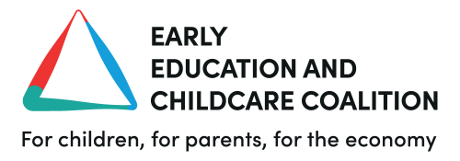

FOR IMMEDIATE RELEASE

Budget 2024: EECC welcomes childcare funding certainty but calls on Government to do more to deliver the upcoming expansion.

6th March 2024, Sarah Ronan, director of the Early Education and Childcare Coalition, comments on today’s Budget:

“We’ve been calling on the Government to index funding rates to inflation and wage growth for quite some time so we’re pleased that the Chancellor has listened to us and offered some certainty to providers over the next two years.

A ‘sector-specific indexing metric’ isn’t a sexy policy but it is a sensible one. In the long run, it has the potential to help both childcare providers and parents providing, of course, that Government gets the calculation of the metric right, which we’re still waiting to see. Much of the shortfall in funding has developed because the cost of delivery has outstripped the funding that providers receive. This results in providers having to increase fees for parents to plug that gap.

Introducing an indexing mechanism is an important step in countering that dynamic and opens the door to a much more sustainable approach to how we fund early education. Moreover, this approach is encouraging recognition of the very specific pressures that face the early years sector. In this election year, it is now vital that all political parties commit to ensuring funding rates are permanently indexed to inflation and wage growth.

That said, it is disappointing that today’s announcement was not accompanied by an increase in funding for current rates, especially three and four-year-olds, which are critically low, as well as a new workforce strategy.

It’s also quite surprising that a budget focused on growth had nothing aimed at growing the early years sector. Many providers are small businesses often founded by the kinds of entrepreneurs that the Chancellor himself so admires. Growth requires investment and we still lag far behind the OECD average. If the Government really wants to deliver on the promise of this childcare expansion, we need realistic levels of investment and a commitment to reforming the current model so it delivers for everyone especially those families that can benefit the most.

We’re hopeful that today’s announcement, including changes to how funding rates are distributed by local authorities, signals a willingness by Government to work closely with all stakeholders to achieve this.”

Notes to editors
For further comment, please contact 07587228151 or sarah@earlyeducationchildcare.org

About the Early Education and Childcare Coalition:
The Early Education and Childcare Coalition is an independent group of more than 30 organisations that unites the voices of parents, children, providers, those working in the sector and the wider business community. Our vision is of an early education and childcare sector that provides high-quality, affordable provision for all families in all communities, and with it, good pay, conditions, and funding for those providing that education and care. We use our collective voice and research to build public and political support for early education and childcare. To learn more about the Coalition, its members and its aims, please visit www.earlyeducationchildcare.org

