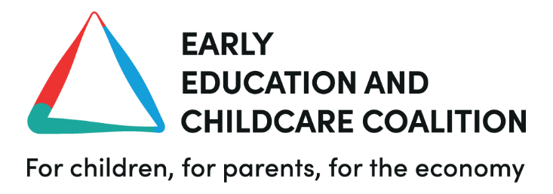

EMBARGOED TO WEDNESDAY 24 APRIL 2024 AT 00.01

EECC Director Sarah Ronan’s response to today’s NAO report on early years entitlements for working parents in England:
“Today’s NAO report highlights the long-term problems and the inequality issues being perpetuated by the current ‘free hours’ early education and childcare model.

“As we detailed in our evidence to the NAO, the expansion continues to lock out the most disadvantaged children and widen the educational attainment gap. The report states that the Department for Education knows that this is the case. Continuing to expand the hours model with no plan for fundamental reform is a political choice to preside over inequality and disadvantage. We have to do better than this or we’ll store up problems for the long-term that the rest of our public services will have to deal with.

“The lack of funding or planning around a proper workforce strategy for early years is also certain to lead to more talented, passionate professionals becoming disillusioned and exiting the sector. The NAO highlights the DfE’s current recruitment campaign, but that is not a substitute for a workforce strategy.

“Ultimately it’s children that will pay the price for the lack of planning, funding and ambition in our early years.”

Further information
- Analysis published in November by the New Economics Foundation (NEF) showed that very few poorer households would be able to access the full 30 ‘free hours’ for under five-year-olds, and that 44% of children in this age range live in local authorities considered ‘childcare deserts’ where there is only one early education place available for every three children.
- EECC’s own research has found that only 17% of nursery managers said they would be able to increase the number of places at their settings once this year’s expansion kicked in – meaning more families competing for the same number of places.
- The Department for Education estimate that 40,000 additional staff will be needed in the next year, however the figure may be closer to 50,000 when considering historical data, trends and turnover of staff.
- The NAO’s report shows that the workforce will need a 12% increase, when historically the sector has only seen increases around 5% per year.
Early Education and Childcare Coalition recommendations:
- A workforce strategy based on retention and recruitment – ensuring there is funding, support and resource for early years professionals to be rewarded through salary and through opportunities for personal training and development in the sector.
- Equality of access – so that every child in every part of the country as an equal opportunity to access early education and benefit from the experience.
- Choice for parents through proper accessibility and affordability - every parent deserves the opportunity to make choices about their work-life balance, and use early education as a key setting in their child’s life without having to over-rely on it, or not be able to access it at all.
- More funding for the sector and reform to create a structure where the early years workforce and the families reliant upon them can be supported.
- Finally, the EECC recommends that this report should be widened to include a full independent review of the sector, its funding and how its accessed.

Notes to editors
For all press queries or more information on the above please contact:
Matthew Mountford, Communications and Campaigns Manager

Email: matthew@earlyeducationchildcare.org
Phone: 07989660487
www.earlyeducationchildcare.org
About the Early Education and Childcare Coalition (EECC)
The Early Education and Childcare Coalition (EECC) is a group of 36 member organisations, all united under the common goal of reforming and improving the early education and childcare sector in the United Kingdom.
- The EECC was officially launched in 2023, following over a year of collaboration and building support in the sector. The 36 member organisations include non-profit organisations, children’s charities, parent campaign groups, membership bodies, anti-poverty campaigners, trade unions and business lobbying groups.
- The Coalition sits under the Women’s Budget Group, the UK’s leading feminist economics think tank. The EECC is funded by the Kiawah Trust, a charitable foundation working to tackle educational and gender inequality.
- The Coalition aims to be a strong and representative voice for families, the early education workforce, and the millions across the country who aspire to see children get the right start in life via a system which recognises and rewards those who dedicate their careers to it.
- Our vision is an early education and childcare sector that provides high-quality and affordable provision in every corner of the country, accessible to all families. In order to achieve this we also want to see the early education workforce being rewarded for their work and not being left overworked, undervalued and disenchanted.
- Only when providers and their workforces are properly funded and supported will we see accessibility and affordability grow – the change has to begin with identification, investment and infrastructure.
- Supported by a range of policy experts as well as the vast knowledge of our members, we advocate for a ‘rescue and reform’ approach involving short-term measures to stabilise the sector, accompanied by a national programme of reform and investment. Through political lobbying, raising awareness and harnessing collaboration we hope to encourage our leaders to back these changes.

